9 Creative Ways to Make Your Home Look More Expensive
Written by Ashley Carter

Many people dream of buying a brand new home, but in many cases this isn’t an option. If you feel like your home looks drab and inexpensive, you don’t need to spend an arm and leg on upgrades.
A few simple DIY projects can create a space that looks new and on trend.
1. Paint the Floor
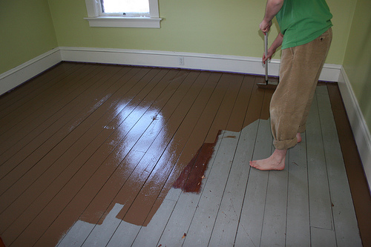Image via Flickr by abbybatchelder
Are you dealing with ugly vinyl or wood flooring that you can’t afford to replace? Paint it instead. Give unattractive old flooring a breath of design, and make an old room look as if it belongs in a beautiful new house. Use porch paint instead of regular wall paint, since porch paint is designed to take foot traffic. Try creating stripes, squares or diamonds with tape to give the floor a unique look. Of course, if you’re pressed for time or money (or both) a single new color will work wonders, too.
2. Redo Outdated Light Fixtures
Ugly light fixtures are a major reason why rooms look drab. Thankfully, you can find inexpensive fixtures online and at your local hardware store. To save money, go for simple, modern fixtures that won’t go out of style anytime soon and that will match many decor styles. If you can afford to splurge a little, a small but chic chandelier in the dining room or bedroom will add a pop of elegance. Do the same with your porch light!
3. Add Window Dressings
Blinds are fine for utility’s sake, but they don’t look very pretty. Even if your current blinds work just fine, hang window dressings anyway. Get stylish curtain rods and pretty curtains that match each room’s decor. Make sure you hang them in a uniform manner. Current styles dictate that your dressings extend about a foot above your window, and at least a few inches past each side. Hanging your dressings high creates the illusion your ceiling is higher than it is. Some people hang their curtains right at the ceiling for a dramatic effect.
4. Put up Crown Moulding
Crown moulding hides the joints between your walls and ceilings. It’s not the sort of detail people notice right away, but it will make your room look and feel more valuable from the get-go. The subtle detail also looks beautiful above bland window frames, and will add an element of elegance to your window dressings, too. Crown moulding is especially attention grabbing if you paint it a different color than the walls and the ceiling to make it stand out. Many go with white, but wood stain looks gorgeous too.
5. Paint Your White Fridge Metallic
Stainless steel refrigerators have been in for many years, and for good reason; They give your kitchen an expensive look. If you can’t splurge on new appliances, get some metallic paint at your local hardware store and paint your white refrigerator’s doors, handles and sides. You can choose paint that mimics stainless steel, or get creative and choose another metallic tint that matches your kitchen’s existing decor. Brightly colored refrigerators are also in this year. Decide what will look best in your kitchen.
6. Paint the Garage to Create a Faux Carriage Door
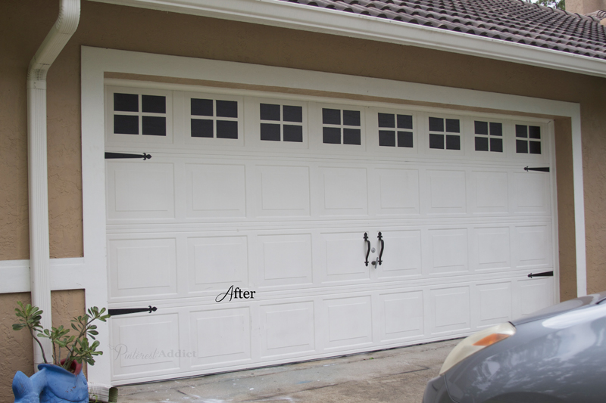Image via A Pinterest Addict
Want a simple, easy way to spruce up your garage door? Paint it to look as if it has windows. If your garage door needs a new coat of paint anyway, take this opportunity to spruce it up and give it a new color. Then, along the top of your garage door, lay out rectangles with painter’s tape.

Cross them with tape, too, to create a window-pane pattern. Use shiny black paint to fill in the small rectangles you’ve created. When you peel off the tape, it’ll look like you’ve got a bunch of tiny windows in your garage door, creating the look of an old carriage house. You can add hardware as a finishing touch.
7. Frame the Television
Why bother with a boring wall mount or a plain TV stand when you can frame your television? If you’re up for it, you can build a frame to fit your television. Because that’s the kind of DIY project that not everyone can handle, you can also find a frame significantly bigger than your television and simply place it on the wall around your television.

Or consider framing some of your favorite artwork in thin frames that look something like your television’s existing plastic frame. Then hang that artwork around your television so that it looks like another part of the wall art.
8. Cover Old Floors With Laminate
If you’re sick of your carpet or old tile, but don’t have the budget for real hardwood floors, try laminate flooring as a temporary, much less expensive option. You can place the laminate right on top of your old floor for a totally new look!
9. Try Your Hand at Wallpaper

Wallpaper is the perfect way to add some personality to your walls and make your home look more expensive. If you’re a commitment phobe, try a removable wallpaper that you can easily switch out.
You don’t have to spend a lot to make your home look chic and expensive. Some smart shopping and a fun weekend of DIY projects is all it will take to spruce up some of the parts of your home you’re not happy with.

