7 Ways To Post About Real Estate Without Boring Your Audience To Tears
Lightersideofreal estate.com
I know, because I used to be one who needed it.
I’m Mike Bell. If you’re not familiar with me and my story, let me give you the extremely short version to establish some credibility here:
Five years ago I created the Lighter Side of Real Estate from scratch, and I built it into what it is today — the most engaged real estate brand on social media.
Here’s the average number of folks I reach, on average, with every post.
I’m not sharing with you bers to brag, but instead to show that I know what I’m talking about. I’ve earned my stripes.
I used to be an agent and appraiser… I did both. For years.
And the content I wrote and stuff I shared online to “build my brand” was awful.
It’s not that it was bad content in and of itself. It was just boring…
…Technical
…Formal
…Blah
Nothing exciting, funny, humorous, or remotely interesting. Not the type of stuff you’d click on or want to share.
Sound familiar?
All agents share the same frustrations when it comes to marketing their real estate business. How do I know?
Because they tell me so.
Making real estate sexy is tough.
So what’d I do?
I started The Lighter Side of Real Estate in 2013.
I love the real estate world. Always have, always will. And precisely because of my affection for you (get your mind out of the gutter), I want to give you some tips on how to market yourself.
Because if you do it correctly, you can post about real estate to stay top of mind with your followers…
Without boring them.
Without sounding desperate or salesly.
Without annoying them to the point of unfollowing you.
So read on if you want to stay top of mind with your audience the RIGHT way.
Pin
Pro-Tip#1 – Stay on the Periphery of Real Estate – Example: Bestie Row
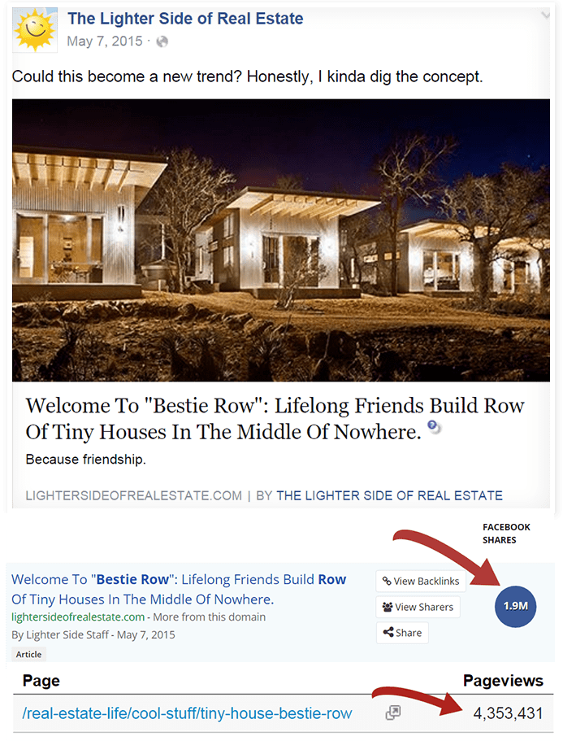Pin
Do you see those shares and pageviews?!
They’re in the MILLIONS — for something shared from a brand that has to do with…wait for it…real estate. Why is this? What’s going on here?
What’s going on is this: Every agent shares the same type of (boring) stuff from the same types of sites. But when’s the last time you saw someone share something like “Bestie Row?”
Q: Does it have to do with “real estate”?
A: Kind of
And that’s why it works.
It gets shared and viewed by people in the real estate biz AND people who aren’t in the real estate biz because it’s just unique enough to be able to live in both worlds. So when you’re thinking through your strategy, find and share stuff that has a foot planted in multiple “worlds” so you can appeal to the most people possible.
Pro-Tip #2 – Trend-Jacking – Example: She Sheds
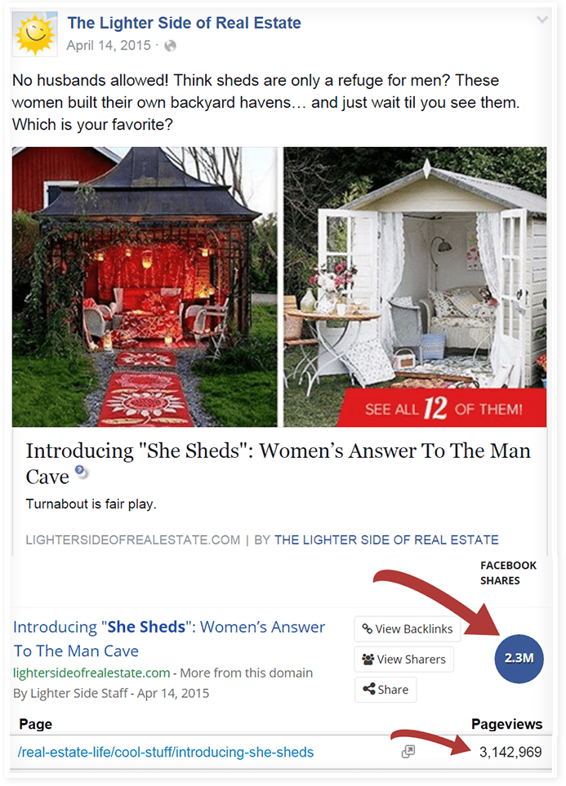Pin
This one’s easy.
If there’s something trending that everyone’s into, find a way to leverage it. The example above is a perfect illustration of how taking a trend (man caves) and tweaking it to appeal to a different demographic or persona can get you A LOT of traction (I mean, a woman’s gotta have her own space too, right?).
The three step process…
- Find cool stuff online (hint: Pinterest).
- Find ways that people are doing the same cool stuff with a different spin on it.
- Write a blog or social media post on it and share it everywhere.
Pro-Tip #3 – News-Jacking – Example(s): Current Events
Remember this controversial issue? It dominated the news cycle.
Pin
What about this one?
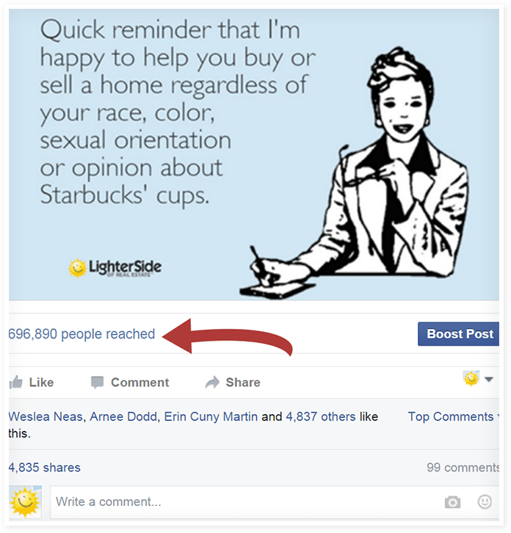Pin
The jackpot is ALWAYS buzzworthy when it reaches a gargantuan number…
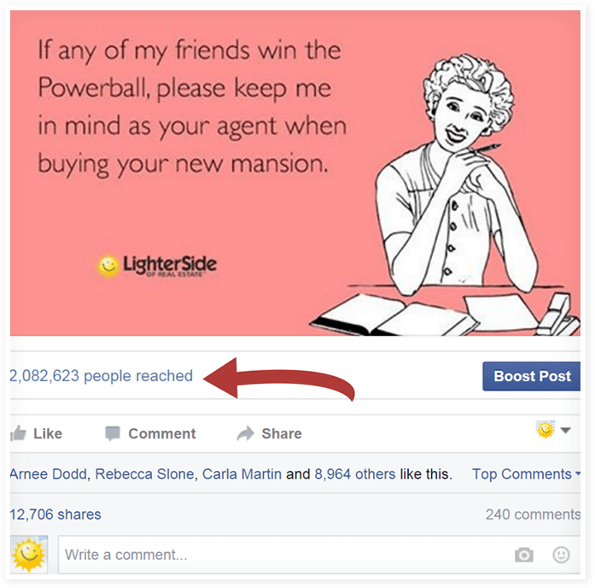Pin
IMPORTANT:
- You can do this and have folks on one side of the hate you.
- You can do this (regardless of your opinion) in a way where you stay neutral.
- Do #2.
Now, no matter how neutral you try to be, you’ll have a few dissenters pop up but from what I’ve experienced, you can’t please everyone all the time. So pick an issue and use it as a catapult to promote yourself.
Remember – your goal is to be INTERESTING, not businessey or salesy…
And when you do? Shares, comments, and likes will abound….
Ask me how I know.
Pro-Tip #4 – Holiday-jacking – Example: Groundhogs Day
Pin
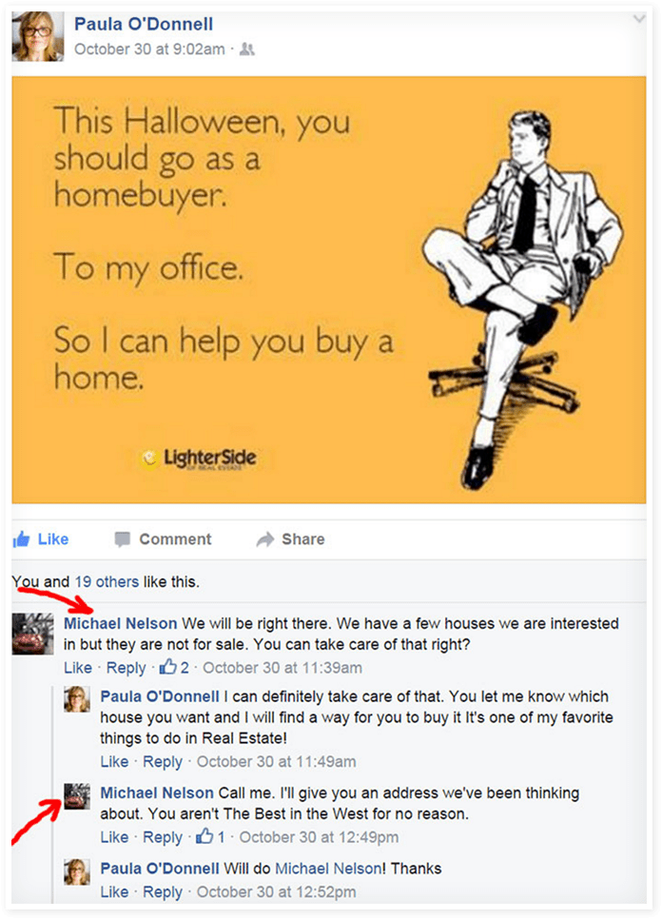Pin
You see a trend here?
You don’t have to reinvent the wheel (side note: if you did, I’d be impressed). You need to find stuff that’s already on everybody’s mind and make it about real estate. Heck we did this with Groundhog’s Day of all things and look at the shares and reach on that post!
This helps you connect with your prospects because it shows them that you’re a real person who can be funny when you need to be…
…just like…them!
P.S. Pro-tip: the more obscure the holiday, the better. Of course you need to do this with holidays like Christmas and Halloween, but do it with the weird or lesser-known ones too (e.g. National Librarian Day).
Pro-Tip #5 – Tell Some Stories: Examples

You love a good story right?
Of course you do. Everyone does. So why is it then, that most real estate agents don’t tell more of them? People (especially your potential clients) LOVE stories. It’s how we communicate deep truths, make a point, express meaning, and oh yeah…sell houses.
This can be done through blogs, social media posts, images, videos, or a combo of all of them. You have stories to tell about your business, your family, and your clients right? Like that one guy from the duplex you were showing who always smelled like cheese (but it was a different kind of cheese each time…odd).
People connect through story.
They binge watch shows on Netflix until 2 a.m. to get their fix.
They crave it… so let ‘em have it.
Pro-Tip #6 – Why So Serious? – Example: Koalafications
Pin
Check out the first comment on that picture. it’s proof that when you’re light and fun, your followers appreciate it. Nobody likes someone who is boring, stiff, and dull all the time right? People enjoy other people who don’t take themselves so darned serious all the time.
It’s refreshing to find people like that (especially in real estate) because we don’t feel threatened (or bored) by them. We let our guard down a bit when we’re around people who are casual.
Real estate needs fun (desperately)…
…so be fun.
Pro-Tip #7 – Join my Inner Circle of agents and let me create all the content FOR you… with YOUR branding.
Wait, what?!?!
Yep. It’s true.
It’s a done-for-you real estate content machine filled with searchable, shareable, “just push a button to make it yours and post it” online warehouse of memes, videos, articles and more…
…all branded to you (so YOU get to take all the credit for being clever).
Member’s send me screenshots like this all the time…

